A novel Audio and Visual Ensemble Approach for Violence Detection

Muni Ranjan, Pradeep Kumar, Chetna Gupta1, Jing Tian, Matthew Chin Heng Chua

¹This research was conducted by the Institute of System Science, National University of Singapore. Muni Ranjan, Pradeep Kumar, Chetna Gupta are the masters students at ISS NUS (e0146946@u.nus.edu, e0147017@u.nus.edu, chetna.gupta@u.nus.edu)

Abstract— This paper presents the research results towards a surveillance system for detection of violent events for citizen’s security in public places, adopting ensemble methodologies. There are various visual and audio events, which occurs during the possibly dangerous situations. The system comprises of an ensemble of i) Video Event Detection ii) Audio Event Detection. The main goal of our work was to build a detection system trained on a dataset of video and audio recordings using deep learning. The approach is experimentally tested and validated for binary decision problem of violence detection.

Keywords: 3DCNN, violence detection, classification, deep learning., LSTM, Ensemble, automation, surveillance, public safety

- INTRODUCTION

In the last years, the problem of human action recognition from video has become tractable by using computer vision techniques. Despite its potential usefulness, the specific task of violent action detection has been comparatively less studied. However, human operators are overwhelmed with the number of camera feeds and manual response times are slow, resulting in a strong demand for automated alert systems. ^{[4]}

These systems are used for tasks e.g. surveillance of public places, stadiums or on the stations of public transport. Such detection systems can be very important due to the fact, that human is not able to watch several audio signals simultaneously (person is not able to distinguish to which input source this event appropriates). Another situation is for video signals, where humans is partially able to watch several screens in the same time, and they can identify the screen where some dangerous situation occurs. ^{[2]}

The fundamental problem with surveillance systems is the intelligent interpretation of human events in real-time.^{[3]} In this paper, we present a public surveillance system combining video and audio surveillance that can detect violent events. It can detect violent event in a crowded environment. The interest in violence detection has been steadily growing, and different proposals are already being published in major journals and conferences.

One of the first proposals for violence recognition in video is Nam et al. ^{[9]} which proposed recognizing violent scenes in videos using flame and blood detection and capturing the degree of motion, as well as the characteristic sounds of violent events. Thanasis et al. ^{[1]} proposed a Multimodal and Ontology-based Fusion Approaches of Audio and Visual Processing for Violence Detection in Movies dataset.

Matus et al^{. [2]} proposes MFCC parametrization and HMM based representation of acoustic information. Xinyu et al. ^{[3]} presents a surveillance system for the aging population. Oscar et al. ^{[4]} proposes fast violence detection using video features. Fillipe et al. ^{[5]} is using Spatio-Temporal features for Violence
Detection. Cheng et al. ^{[10]} recognizes gunshots, explosions and car-braking in audio using a hierarchical approach based on Gaussian mixture models and Hidden Markov models (HMM). Radhakrishnan et al. ^{[6]} presented a systematic framework for the detection of abnormal sounds that may occur in elevators. Luo ^{[7]} built a security robot that can detect a dangerous situation and provide a timely alert, focusing on fire detection, power detection, and intruder detection. Giannakopoulos et al. ^{[11]} also propose a violence detector based on audio features. Clarin et al. ^{[12]} present a system that uses a Kohonen self-organizing map to detect skin and blood pixels in each frame and motion intensity analysis to detect violent actions involving blood. Zajdel et al^{. [13]}, introduced the CASSANDRA system, which employs motion features related to articulation in video and scream-like cues in audio to detect aggression in surveillance videos. More recently, Gong et al. ^{[14]} propose a violence detector using low-level visual and auditory features and high-level audio effects identifying potential violent content in movies. Lin and Wang ^{[15]} describe a weakly-supervised audio violence classifier combined using co-training with a motion, explosion and blood video classifier to detect violent scenes in movies. Violence detection has been even approached using static images (Wang et al.) ^{[16]}. A proof of the growing interest is also the MediaEval Affect Task, a competition that aims at discovering violence in colour movies (Demarty et al.) ^{[17]}. In this case the algorithms have access to additional information such as audio, subtitles and previously-annotated concepts. Besides, no comparisons are made about computational times. In summary, several previous works require audio cues for detecting violence or rely on colour to detect cues such as blood. In this respect, we note that there are important applications, particularly in surveillance, where audio and colour are not available. Besides, while explosions, blood and running may be useful cues for violence in action movies, they are rare in real-world situations. In any case, violence detection is an extremely difficult problem, since violence is a subjective concept. Fight detection, on the contrary, is a specific violence-related task that may be tackled using action recognition techniques and which has immediate applications. In (Bermejo et al) ^{[18]} the authors demonstrated encouraging results on violence detection, achieving 90% accuracy using MoSIFT features.

Despite being considered within state-of-the-art action recognition methods, the computational cost of extracting these features is prohibitively large, taking near 1 second per frame on a high-end laptop. This precludes use in practical applications, where many camera streams may have to be processed in real-time. Such cost is also a major problem when the objective is to embed a fight detection functionality into a smart camera (i.e. going from the extant embedded motion detection to embedded violent motion detection). ^{[4].}

The main innovative features of the proposed system, which will be further described in the next sections, are:
•Extraction of discriminative convolutions from videos using 3DCNN.
•Extraction of audio features, specific for violence detection.
•Ensemble of the audio and visual modalities.

- METHODS AND MATERIALS

Our research in violence detection aims towards leveraging 3DCNN for visual information and MFCCS, CHROMA, MEL, CONTRAST, TONNETZ features for audio. A pre-processing step tackles the task of spatio-temporal video segmentation and feeds the low-level audio and visual analysis algorithms with fixed length audio-visual segments of 1-4 seconds, bypassing thus the problem of common timeline representation.

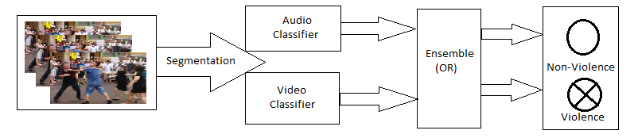

This ensemble approach tackles the binary (violence, non-violence) detection problem. A suitable feature set for representation of sounds plays an important role. The often-used feature set consists of MFCC (Mel Frequency Cepstral coefficients), CHROMA, MEL, CONTRAST, TONNETZ parametrization and their time derivations. This feature set well represents speech spectral structure, but it has limited (but usable) performance for audio event, too.^{[2]} For video classification, 3D convolutions has been used.

3D Convolutions

3D convolutions apply a 3-dimensional filter to the dataset and the filter moves 3-direction (x, y, z) to calculate the low-level feature representations. Their output shape is a 3-dimensional volume space such as cube or cuboid. They are helpful in event detection in videos, 3D medical images etc. They are not limited to 3d space but can also be applied to 2d space inputs such as images.

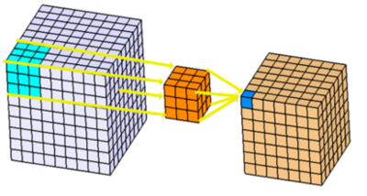
Figure 1: 3D Convolutions architecture

LSTM (RNN)

Sequence prediction problems have been around for a long time. They are considered as one of the hardest problems to solve in the data science industry. These include a wide range of problems; from predicting sales to finding patterns in stock markets’ data, from understanding movie plots to recognizing your way of speech, from language translations to predicting your next word on your iPhone’s keyboard.

With the recent breakthroughs that have been happening in data science, it is found that for almost all of these sequence prediction problems, long short-Term Memory networks, a.k.a LSTMs have been observed as the most effective solution.

LSTMs have an edge over conventional feed-forward neural networks and RNN in many ways. This is because of their property of selectively remembering patterns for long durations of time.

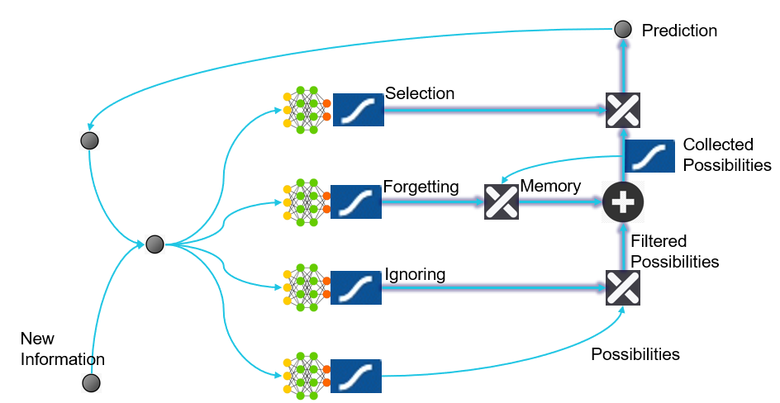

Figure 2: LSTM architecture

- EXPERIMENT

For the detection of visual violent events, the task is a binary classification with the final layer giving the prediction that the given video has violence. The given set of experiments must deal with answering the following - the effectiveness of using 3DCNN to improve the performance using pre-trained models. Since the final aim is to develop a system that can be deployable and can be generalized in a much broader sense, in addition to the above, we need to also look at the ideal architectures that can be used, the elements within architectures that are detrimental to the performance for the given task, the selection of loss function such that it can be used for a variety of videos and finally make the models interpretable for future use.
The audio classification feature extraction and 3DCNN video classification based fusion method have been implemented in Python. The visual-related features have been extracted using the OpenCV library.

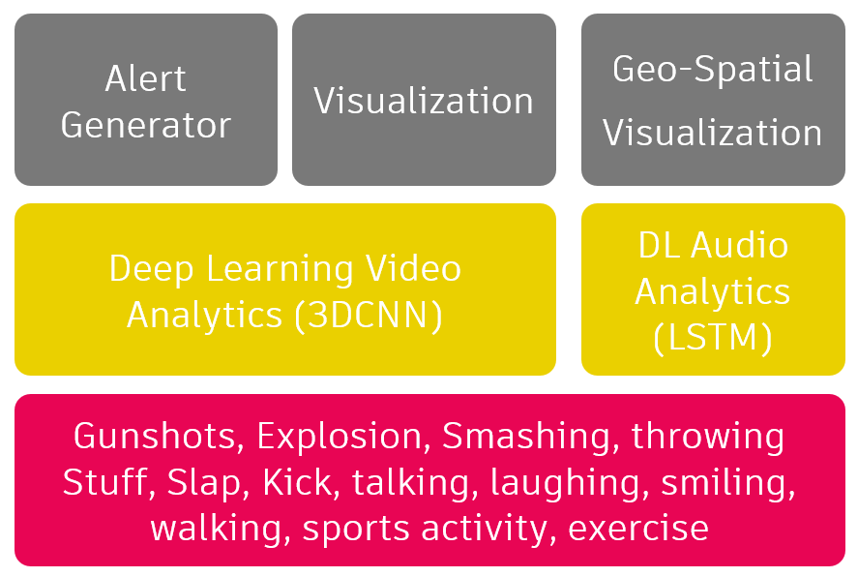
Figure 3: Block Diagram

Here the models are trained for 50 epochs on each model. For video frames, we resized them in to 32x32 size and extract the 15 frames from videos of length 2-4 seconds. Then, we pass this series of frames to 3DCNN model using softmax activation followed by Relu in different stages. We tweak the value of dropout between 0.15 to 0.35 for different iterations in order to make sure, we handle the issues mentioned below:
- Low accuracy – if dropout set to too low
- Overfitting - if dropout set to too high
Similarly, we extracted the audio features mentioned below from the same video streams:
- MFCC, Chroma, Contrast, Tonnetz, Pitch
Then we pass these features to LSTM model. Here we again kept the dropout value between 0.2 – 0.35. We also used Softmax as activation for 50 epochs.

We used the OR operator as ensemble of classification from predicted results of audio and video.

The results are presented in the next section.

IV. RESULTS AND DISCUSSIONS

We split our dataset in to 80:20 train/test ratio. In total there were 2 types of videos datasets were used (Mute and with Non-mute). The following results are observed on Video dataset using 3DCNN

Videos with No Audio

 | Actual/Predicted | Violence | Non-Violence
 | Violence | 197 | 24
 | Non-Violence | 18 | 243

Table 1

 | Accuracy | Precision | Recall | F1-score
Dfdffdf
 | 0.913 | 197 | 24 | 0.9

Table 2

Videos with Audio

 | Actual/Predicted | Violence | Non-Violence
 | Violence | 30 | 8
 | Non-Violence | 6 | 51

Table 3

 | Accuracy | Precision | Recall | F1-score
Dfdffdf
 | 0.83 | 0.78 | 0.81 | 0.86

Table 4
Audio Only

 | Actual/Predicted | Violence | Non-Violence
 | Violence | 35 | 3
 | Non-Violence | 11 | 46

Table 5

 | Accuracy | Precision | Recall | F1-score
Dfdffdf
 | 0.76 | 0.92 | 0.83 | 0.853

Table 6

Ensemble (OR Operator)

 | Actual/Predicted | Violence | Non-Violence
 | Violence | 36 | 2
 | Non-Violence | 17 | 40

Table 7

 | Accuracy | Precision | Recall | F1-score
Dfdffdf
 | 0.67 | 0.94 | 0.79 | 0.80

Table 8

- MODEL INTERPRETATION

To interpret the predictions, we also produced the accuracy for 50 epochs and loss function as shown below for final ensemble model:

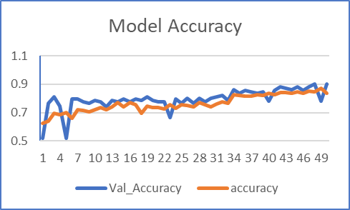
Figure 4: Accuracy over 50 Epochs

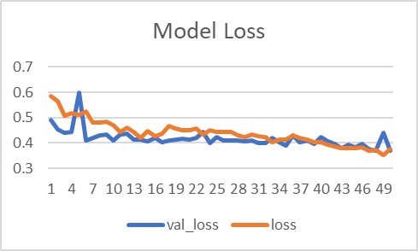
Figure 5: Model Loss over 50 epochs

Here “accuracy” and “loss” are based on training set and “val_accuracy” and “val_loss” are based on validation set. Overall True violence detection rate is high for ensemble approach compared to individual models (Video only or audio only). Overall accuracy for ensemble goes down due to false negatives. For example, if someone shouts at public place casually, then it’s not a violent activity but audio classifier will predict it as violent while video will predict it as non-violent due the “OR” operator. However, for the true violent cases if camera is not able to capture the scene due to its positioning, audio will still detect it hence overall true positives goes up.

VII. CONCLUSION AND FUTURE WORK

We ran our models based on 50 epochs and achieved accuracy of ~80% for ensemble model. One of the challenges we faced were the real videos showing violence with sound. In the future research, We would gather more datasets which is primarily a manual task and refine our ensemble techniques by taking in to account prediction and it’s probability indicating confidence interval.

To summarize, we tried multiple videos combinations and every time 3DCNN is the deterministic factor. Sound (no matter HMM or RNN) might be complimentary to video-based classification. However, video only outperforms video+sound for classification. The experiments help understand the nature of deep learning strategies to be used for videos. We also realized that the usage of appropriate data for pretraining is important and makes the entire process more efficient.

There can be multiple areas in which this work may be taken forward. One obvious question to be answered is how well the system would perform against human counterparts. A human benchmarking against several of these datasets is required to see both the individual performance and the agreement between various human operators. An interesting area of research would be to combine these sources together and come up with an interpretable model which would make use of human inputs as well as the audio+video data.

ACKNOWLEDGMENT

This work is supported by the Institute of Systems Science, National University of Singapore (NUS).

REFERENCES

[1] Perperis, Thanassis, et al. "Multimodal and ontology-based fusion approaches of audio and visual processing for violence detection in movies." Expert systems with applications 38.11 (2011): 14102-14116.

[2] Pleva, Matúš, et al. "Automatic detection of audio events indicating threats." IEEE International Conference on Multimedia Communications, Services and Security, Krakow. Vol. 6. No. 7.5. 2010.
[3] Wu, Xinyu, et al. "Surveillance robot utilizing video and audio information." Journal of Intelligent and Robotic Systems 55.4-5 (2009): 403-421.
[4] Deniz, Oscar, et al. "Fast violence detection in video." 2014 International Conference on Computer Vision Theory and Applications (VISAPP). Vol. 2. IEEE, 2014.

[5] De Souza, Fillipe DM, et al. "Violence detection in video using spatio-temporal features." 2010 23rd SIBGRAPI Conference on Graphics, Patterns and Images. IEEE, 2010.
[6] Radhakrishnan, R., Divakaran, A.: Systematic acquisition of audio classes for elevator surveillance. In: Proc. of SPIE, pp. 64–71. Austin, 24–26 May 2005.
[7] Luo, R.C., Su, K.L.: A multiagent multisensor based real-time sensory control system for intelligent security robot. In: Proceedings of International Conference on Robotics and Automation, Taiwan, 14–19 September 2003.
[8] Vu, Van-Thinh, et al. "Audio-video event recognition system for public transport security." (2006): 414-419.
[9] Nam, Jeho, Masoud Alghoniemy, and Ahmed H. Tewfik. "Audio-visual content-based violent scene characterization." Proceedings 1998 International Conference on Image Processing. ICIP98 (Cat. No. 98CB36269). Vol. 1. IEEE, 1998.
[10] Chen, Cheng-Yao, Ahmed Abdallah, and Wayne Wolf. "Audiovisual gunshot event recognition." 2006 IEEE International Conference on Systems, Man and Cybernetics. Vol. 6. IEEE, 2006.
[11] Giannakopoulos, Theodoros, et al. "Violence content classification using audio features." Hellenic Conference on Artificial Intelligence. Springer, Berlin, Heidelberg, 2006.
[12] Nievas, Enrique Bermejo, et al. "Violence detection in video using computer vision techniques." International conference on Computer analysis of images and patterns. Springer, Berlin, Heidelberg, 2011.
[13] Zajdel, Wojtek, et al. "CASSANDRA: audio-video sensor fusion for aggression detection." 2007 IEEE Conference on Advanced Video and Signal Based Surveillance. IEEE, 2007.
[14] Nievas, Enrique Bermejo, et al. "Violence detection in video using computer vision techniques." International conference on Computer analysis of images and patterns. Springer, Berlin, Heidelberg, 2011.
[15] Gong, Yu, et al. "Detecting violent scenes in movies by auditory and visual cues." Pacific-Rim Conference on Multimedia. Springer, Berlin, Heidelberg, 2008.
[16] Lin, Jian, and Weiqiang Wang. "Weakly-supervised violence detection in movies with audio and video based co-training." Pacific-Rim Conference on Multimedia. Springer, Berlin, Heidelberg, 2009.
[17] Demarty, Claire-Hélène, et al. "The Mediaeval 2011 affect task: Violent scene detection in Hollywood movies." MediaEval 2011 Workshop. 2011.
[18] Nievas, Enrique Bermejo, et al. "Violence detection in video using computer vision techniques." International conference on Computer analysis of images and patterns. Springer, Berlin, Heidel

